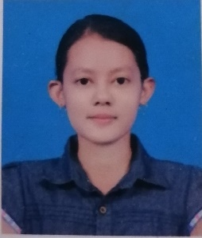

Dear HR manager:

I am submitting my application for the entry-level position. I am final Year Student at University of Computer studies (Pathein), which gave me proficiency in HTML, CSS , Javascript , Bootstrap , Wordpress and Java. My education and experience are a great fit for what you need.

Solid knowledge of different programming languages including JavaScript, HTML, CSS, C++ and Java. Knowledge on software lifecycle management and code organization. Passion for programming and ability to learn new technologies. Capable of understanding client requirements, and developing project specifications. Sound knowledge of software testing and deployment. Good interpersonal and communication skills. I’m good at used in wordpress. I’m solid knowledge of digital ocean server (DNS) and GoDaddy server (DNS).

My passion for designing and coding software is what drives me to pursue a career at your company and my eye for design and user-driven approach to development makes me an ideal candidate. If you think I’d be a good fit for your need, then please reach out to set up an interview at your earliest convenience.

Sincerely,

Ms. Thet Htet Soe

|  |  |
| --- | --- |
|  | **Ms. Thet Htet Soe**  No.65(B), Kyaung Kone(2) Street, Than Lan,Hlaing Township, Yangon Myanmar  09965707240, 09 983381802  thethtetsoe789@gmail.com |

|  |  |
| --- | --- |
|  | Objectives  An entry-level developer position that utilizes my technical skills, education, business experience and transforming complication into simplicity. I’m willing to learn new technologies.  Education   * Final Year Student in University of Computer Studies (Pathein) * Java Basic Certification(Northern City Computer Training Center * Web Design Certification(Northern City Computer Training Center)   Summary of Skills  Computer Programming Languages: JavaScript, HTML, CSS, C#, C++, Java  Databases: MySql  Operation systems: Window  Domain Name Server: Digital Ocean Server, GoDaddy Server  Experiences  Junior Web Developer At Design Printing Services(DPS)  Additional Skills  Microsoft Word  Microsoft PowerPoint  Microsoft Excel  Photoshop |

|  |
| --- |
|  |